Problem: *Sock Merchant*

John works at a clothing store and he's going through a pile of socks to find the number of matching pairs. More specifically, he has a pile of  loose socks where each sock  is labeled with an integer, , denoting its color. He wants to sell as many socks as possible, but his customers will only buy them in matching pairs. Two socks,  and , are a single matching pair if they have the same color ().

Given  and the color of each sock, how many pairs of socks can John sell?

**Input Format**

The first line contains an integer, , denoting the number of socks.   
The second line contains  space-separated integers describing the respective values of .

**Constraints**

**Output Format**

Print the total number of *matching pairs* of socks that John can sell.

**Sample Input**

9

10 20 20 10 10 30 50 10 20

**Sample Output**

3

**Explanation**

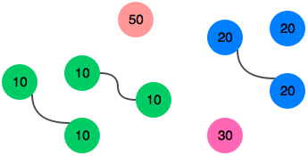

As you can see from the figure above, we can match three pairs of socks. Thus, we print  on a new line.

*Solution:*

int main()

{

int socks, pair=0;

cin>>socks;

int color[socks];

/*Feeding the data*/

for( int i=0; i<socks; i++)

{ cin>> color[i] ; }

/*Matching up*/

for(int i=0; i<socks; i++)

{ if(color[i]==0)

{ continue; }

else

{

for(int j=i+1; j<socks; j++)

{ if( color[i]==color[j])

{pair+=1;

color[i]=0;

color[j]=0;

break;

}

}

}

}

cout<<pair;

} - Anshul Aggarwal